# Lab: Inheritance

Problems for exercises and homework for the ["Java OOP Basics" course @ SoftUni](https://softuni.bg/courses/java-oop-basics).

You can check your solutions here: <https://judge.softuni.bg/Contests/Practice/Index/478#0>.

# Part I: Inheritance

## Single Inheritance

Create two classes named Animal and Dog.

Animal with a single public method eat() that prints: **"eating…"**

Dog with a single public method bark() that prints: **"barking…"**

Dog should inherit from Animal.

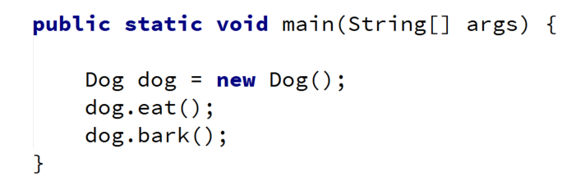

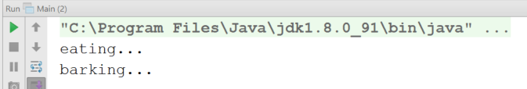

### Hints

Use the extends keyword to build a hierarchy

## Multiple Inheritance

Create three classes named Animal, Dog and Puppy.

Animal with a single public method eat() that prints: **"eating…"**

Dog with a single public method bark() that prints: **"barking…"**

Puppy with a single public method weep() that prints: **"weeping…"**

Dog should inherit from Animal. Puppy should inherit from Dog.

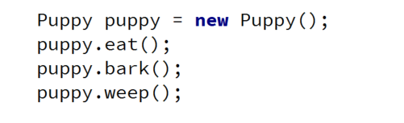

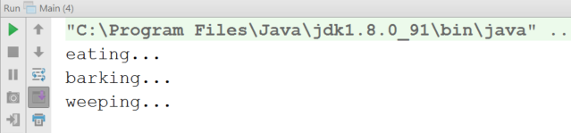

## Hierarchical Inheritance

Create three classes named Animal, Dog and Cat.

Animal with a single public method eat() that prints: **"eating…"**

Dog with a single public method bark() that prints: **"barking…"**

Cat with a single public method meow() that prints: **"meowing…"**

Dog and Cat should inherit from Animal.

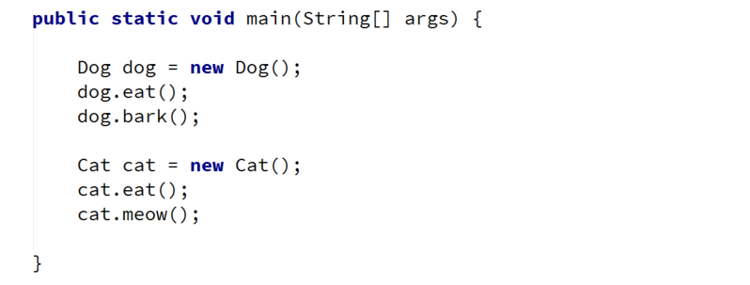

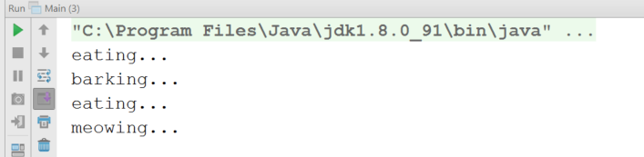

# Part II: Reusing Classes

## Fragile Base Class

Create three classes named Animal, Predator and Food.

Predator should inherit from Animal.

Animal:

* Protected field: foodEaten: ArrayList<Food>
* Public final method: eat(Food): void
* Public method: eatAll(Food[]): void

Predator:

* Private field: health: int
* Public method: feed(Food): void

Food:

* Just an empty class

**Note:** First, make eatAll() to use eat() to do its job. Do not make the eat() method final. override eat() in Predator. Now if you change the implementation of eatAll() (to no longer use eat(), you can use Collections.addAll()) you should observe a bug introduced in you program.

## Random Array List

Create a RandomArrayList class that has all the functionality of an ArrayList.

Add additional function that **returns** and **removes** a random element from the list.

* Public method: getRandomElement(): Object

### Hints

## Stack of Strings

Create a class Stack which can store only strings and has the following functionality:

* Private field: **data: ArrayList<String>**
* Public method: push(String item): void
* Public method: pop(): String
* Public method: peek(): String
* Public method: isEmpty(): boolean

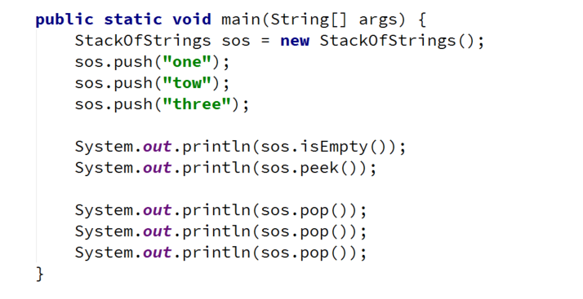

### Hints

Use composition/delegation in order to have a field in which to store the stack's data